Thathsara K.P.W.P.T

Lab 6-IT24102334

Exercise

Question 1

1,2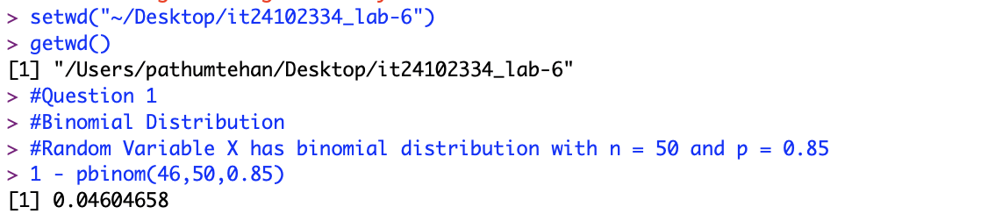

Question 2

1.

2.



3.

